ACTIVITY-09(Lab-04)

**Name**:- Abhishek Srivastava

**Reg. No**:-19BCE10071

**Slot**:- A21+A22+A23

Q. Implement one-way and two-way ANOVA by considering any scenario and investigating the computational analysis of one-way and two-way ANOVA to estimate the P-value to take a decision.

**# Performing One Way ANOVA test in R**

**1.**

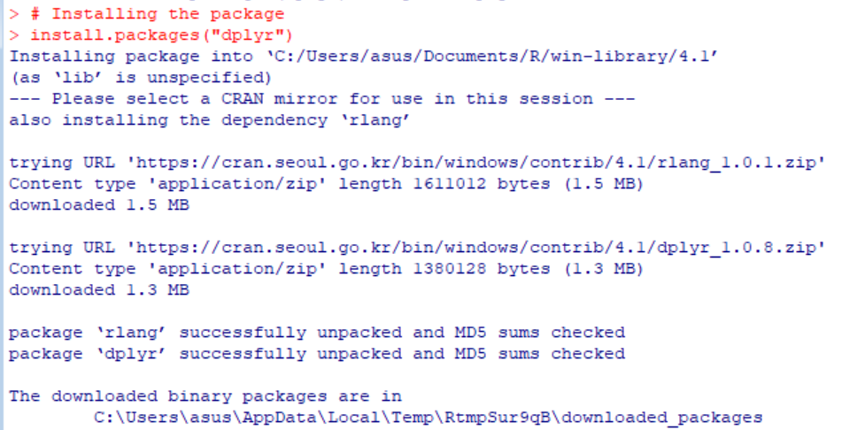

**2.**

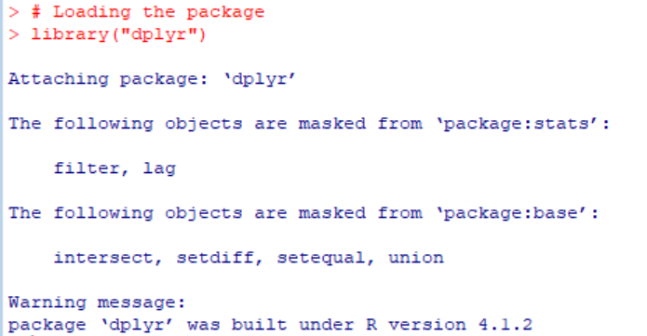

**3.**

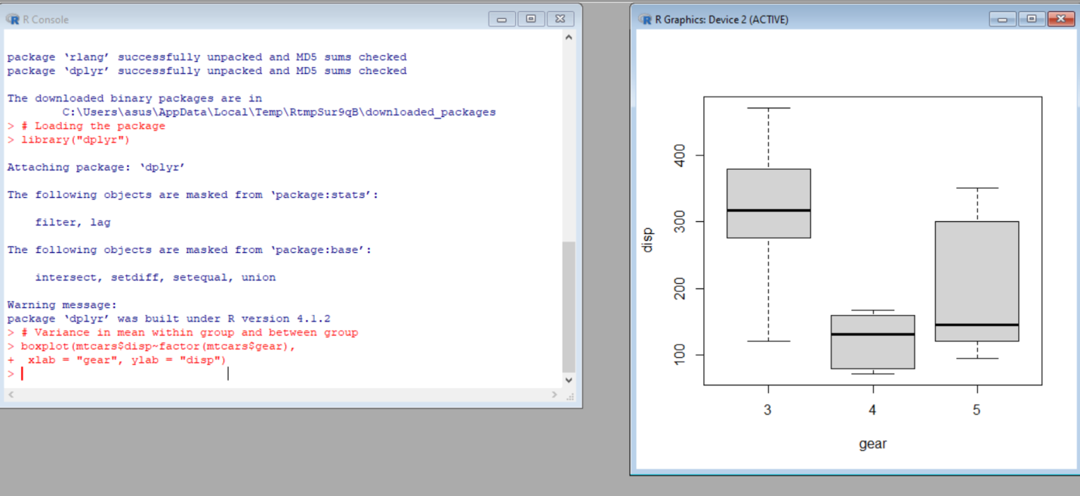

**4.**

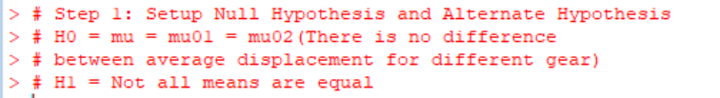

**5.**

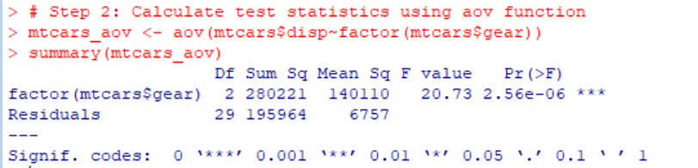

**6.**

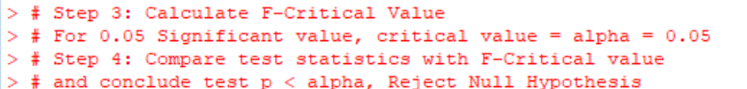

# Performing Two Way ANOVA test in R

1.

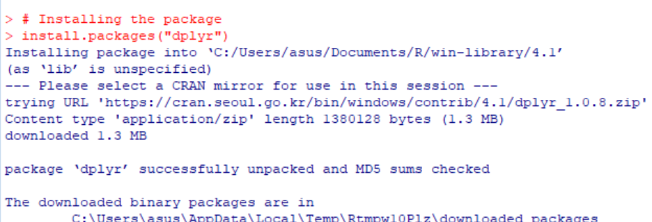

2.

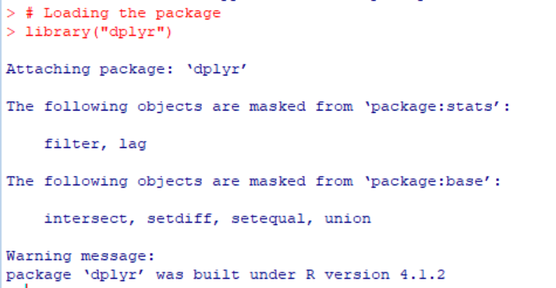

3.

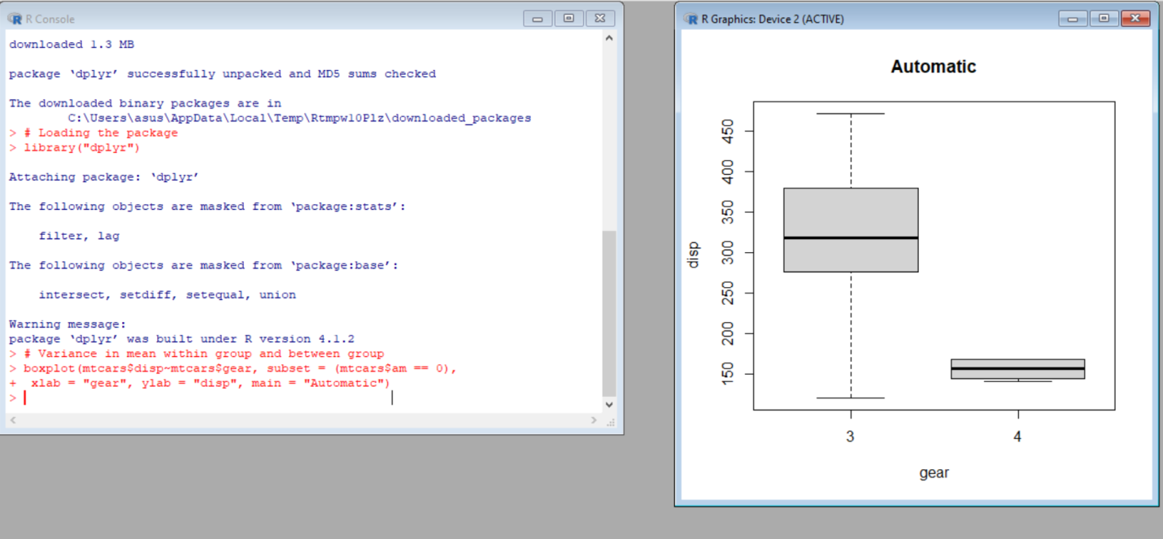

4.

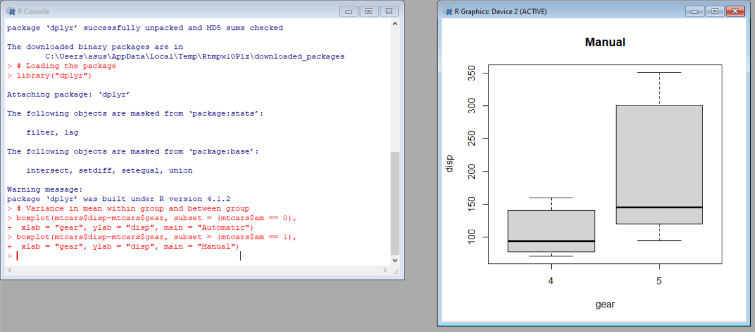

5.

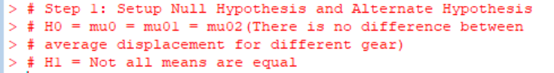

6.

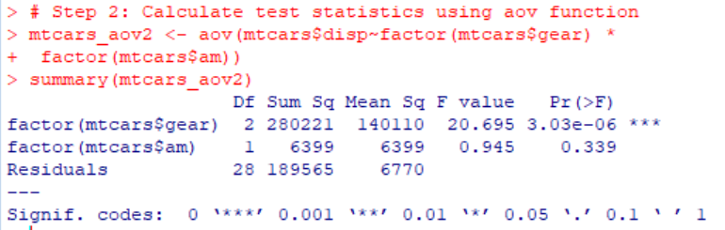

7.

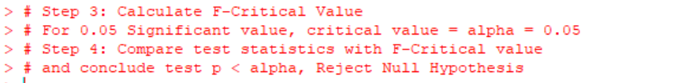

bcdedit/set hypervisorlaunchtype off